|  |  |  |  |  |  |  |  |  |  |  |  |
| --- | --- | --- | --- | --- | --- | --- | --- | --- | --- | --- | --- |
| **Mapbox Studio Components** | | **Zoom Levels** | **Form** | | **Color** | | **Type** | | **Texture** | | |
| **Administrative Boundaries**   * *admin-0-boundary* * *admin-1-boundary* * *admin-0-boundary-disputed* | | [roughly plan when these layers may toggle on and off when zooming] | [paste example crops from your inspiration board here; you do not need to fill out every box, rather this plans which OSM layers might make the most sense to recreate your visual style] | | Black outlines for any that are definitive (like continents) | |  | | Solid, with very slight variation in widths (to add a wobble look) | | |
| **Buildings**  **(including labels)**   * *block-number-label* * *building-number-label* * *building* * *building-extrusion* * *building-underground* | | At a middle zoom | Pulled from Kate Leroux | | Grey and white, with copper borders | |  | | Subtle smooth lines, with a milky finish, similar to that below | | |
| **Land** & Water   * *land* * *landcover* * *national-parks* * *landuse* | | Present all times, developed land only at a mid zoom | Henry Knight    Kate Leroux    Kate Leroux    Kate Leroux    Kate Leroux | | Variations of green to symbolize the different land types with black borders  National parks, dark green  Landcover, clover green  Land, beige/brown maybe  Landuse, [if this is developed land], grey | |  | | A bumpy kind of texture, to reflect the variability in a tree canopy or a patch of grass. Adjusting to have bumpier texture for forested areas vs smoother bumps for landcover | | |
| Land & **Water**   * *water* (+ shadowing) * *waterway* (+ shadowing) * *land-structure* (structures on the coastlines; lines and polygons) | | Present all times | San Diego art collective    Kate Leroux    San Diego Art collective | | Shades of blue with black borders  [If can differentiate between different classifications of water bodies, I want a different color for each]  Ocean, dark blue  Seas, dark blue in a slightly lighter shade  Waterway, lighter blue | |  | | Wavy texture, maybe oriented not horizontally. Pulled from Henry Knight | | |
| **Natural Features (Labels)**   * *water-point-label* * *water-line-label* * *natural-point-label* * *natural-line-label* * *waterway-label* | |  |  | | Point labels, circles with colors that match with color scheme of the above classifications  Type in black | | Italianno Regular | |  | | |
| **Place Labels**   * *country-label* * *state-label* * *settlement-major-label* * *settlement-minor-label* * *settlement-subdivision-label* | | Each can appear when the extent of areas fills the window |  | | Yellow with black outline for country labels and state labels (difference in size?)  Black for all other type | | Serifs with case change and size change  Rosella (in the solid setting    (Look for google font version to download) | | Maybe scratches where major settlements are? | | |
| **Points of Interest**   * *poi-label* (text or icon; Maki is used by default) | | Mid zoom? | (With purple instead, additional colors can be added if there is a way to rank them) | | Purple circles with thick silver border (also representing that it has permanence, but separate from the black borders denoting physical shapes) | |  | | Something frosty (pulled from the solid colors cathedral pane) | | |
| **Mapbox Studio Components** | **Zoom Levels** | | | **Form** | | **Color** | | **Type** | | **Texture** |
| **Road Network**  **(including labels)**  Complex hierarchy avail within the following categories:   * *road-labels* * *bridge* * *turning-feature* (e.g., one-way) * *road* * *tunnel* | Only on large scale zooms | | |  | | Copper (to symbolize that they are in progress and not set in stone) | |  | | Anything to add a touch of shine |
| **Satellite Imagery**   * *satellite* (can fade in a largest zoom level) * *background* | **Not relevant** | | | **Not relevant** | | **Not relevant** | | **Not relevant** | | **Not relevant** |
| **Terrain**   * *hillshade* * *cliffs* * *contours* | **Not relevant** | | | **Not relevant** | | **Not relevant** | | **Not relevant** | | **Not relevant** |
| **Transit (including labels)**   * *aerialway* * *bridge-raile-tracks* * *bridge-rail* * *road-rail-tracks* * *road-rail* * *ferry-auto* * *ferry* * *aeroway-line* * *aeroway-polygon* | **Not relevant** | | | **Not relevant** | | **Not relevant** | | **Not relevant** | | **Not relevant** |
| **Walking, Cycling (including labels)**   * *bridge-pedestrian* (+ many related categories) * *golf-hole-line* * *road-pedestrian* (+ many related categories) * *tunnel-pedestrian* (+ many related categories) | Only at large scale zooms | | | Pulled from Kate Leroux example | | White with copper outlines | | Serif with italics? | | Some opaque, flat looking stripes |
| **Custom Datasets**  Mapbox Studio supports csv, geojson, kml, gpx, shapefile, and geotiff formats. All custom datasets must first be reprojected into Web Mercator (EPSG:3857) |  | | |  | |  | |  | |  |
| **Background Layer** |  | | |  | |  | |  | |  |

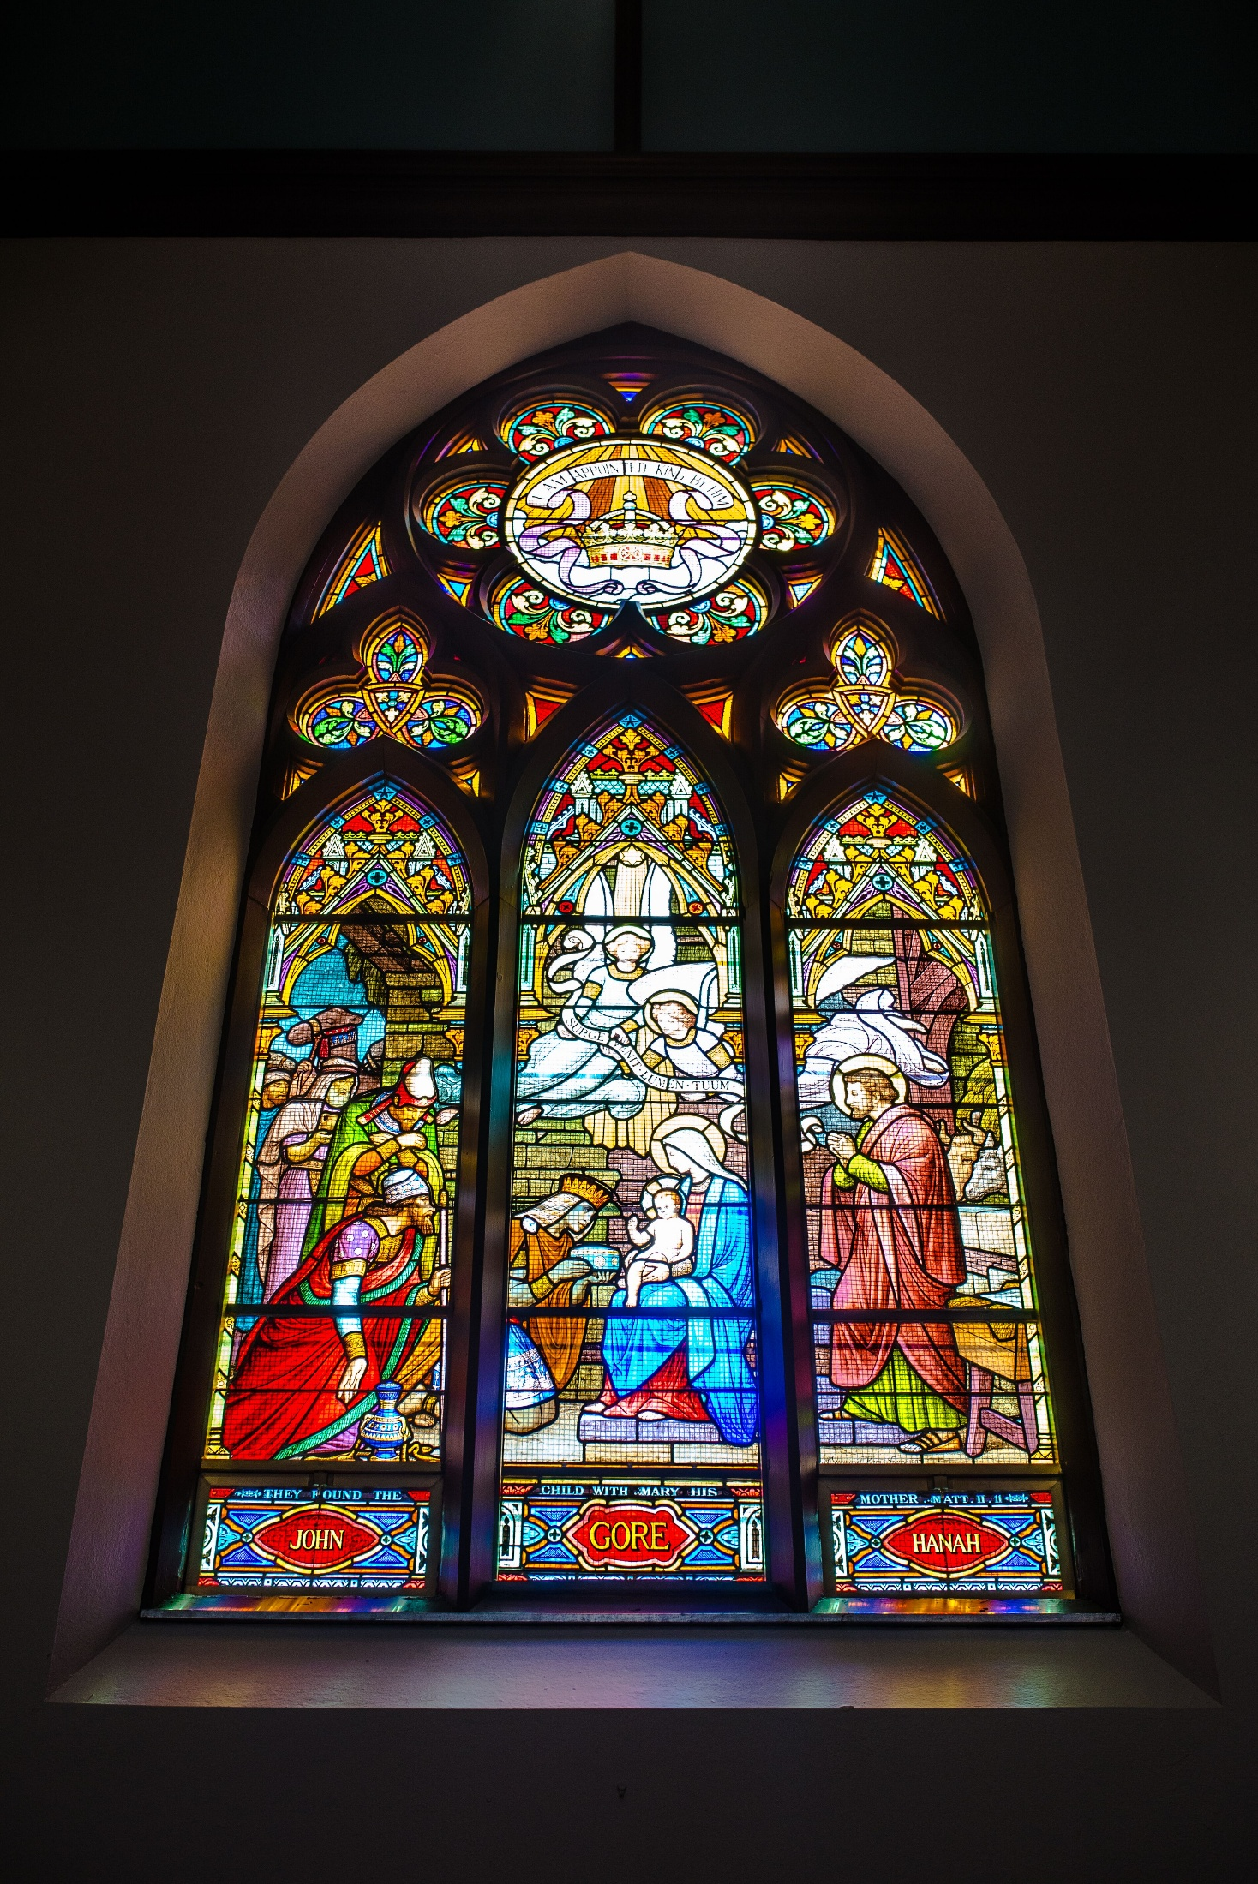

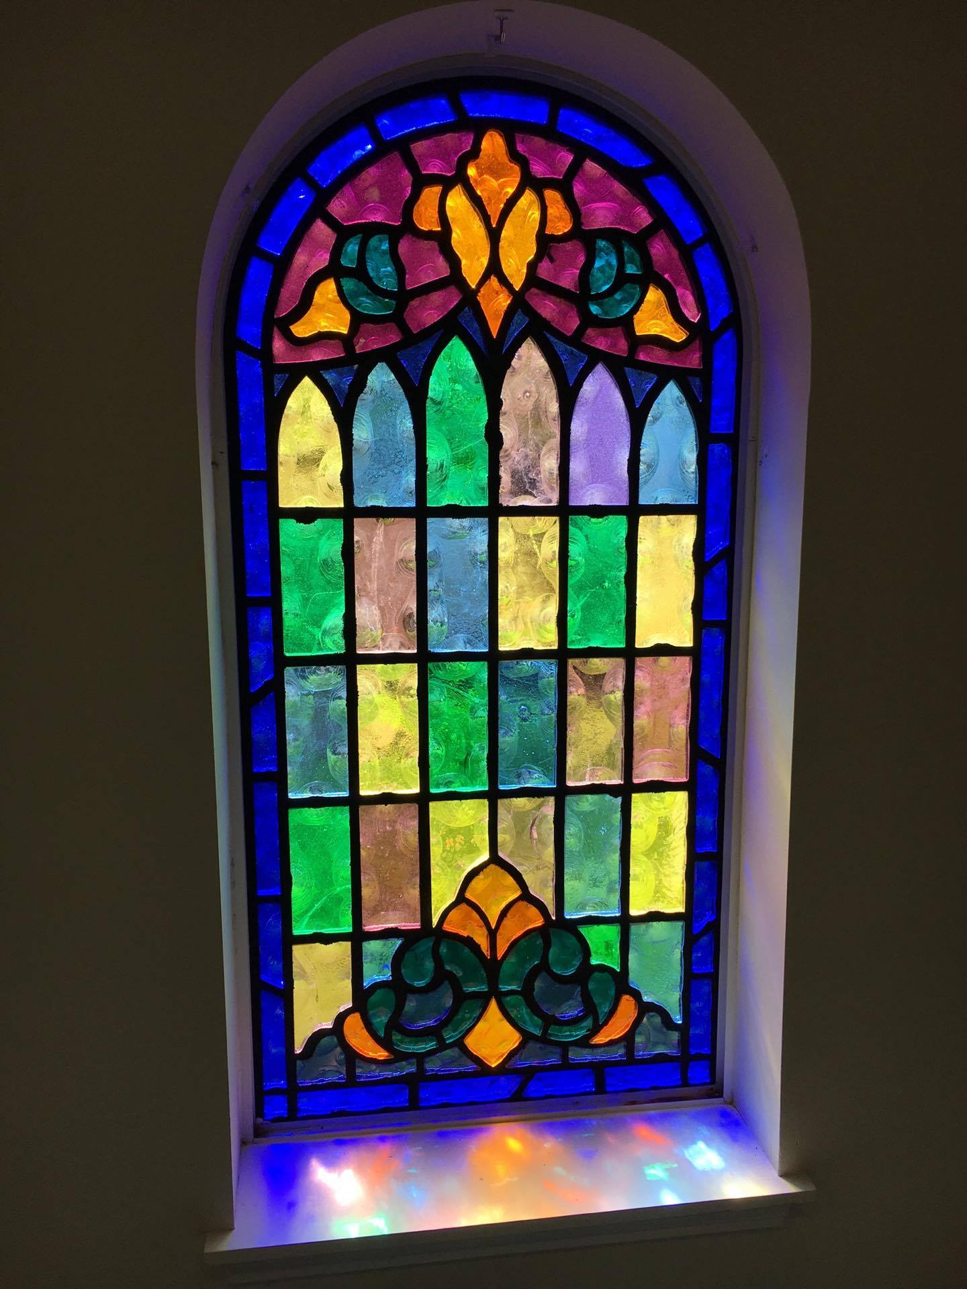

Kate Leroux, digital stained glass map of Tacoma

<https://www.henryknight.ca/maps> Real stained glass maps, info on the design process here

San Diego art collective

W. Bogtman

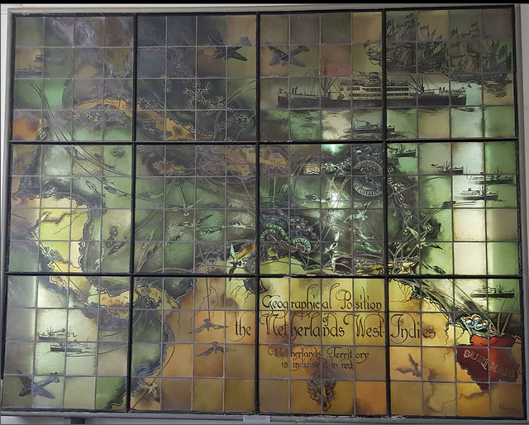

**For creating**

<https://docs.mapbox.com/mapbox-gl-js/example/fill-pattern/>

Code to add a textured fill